EXECUTIVE DIPLOMA IN PURCHASING

REGISTRATION FORM

Session: 2023-2024
Please fill-in this form (one per participant) and return it to Ms Natalia Savitcaia: natalia.savitcaia@eipm.org

Participant information
Ms Mr First name: Last name:
Email: Phone:
Job title: Company:
Address:
City: Postal Code: Country:
Programme: Learning path scheduling, learning mode & price

Step 1 | Step 2 | Step 3 | Step 4 | Step 5
1st course:  “Purchasing Strategy & Organisation” | 2nd course:  “Leading Purchasing Transformation” | EIPM  Annual Conference | EIPM  Master Class 2024 | Project  Presentation slots:
Venue: EIPM Archamps Campus  03.07 – 07.07. 2023 | Venue: EIPM Archamps Campus  28.08 - 01.09. 2023 | Venue: TBC  14-15.12.2023 | March 2024  Date & venue TBC | Oct. 2024  Feb. 2025
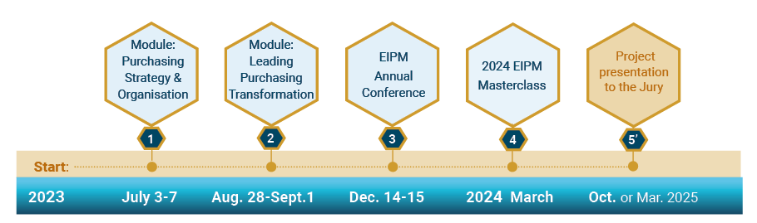
Tuition fee: EUR 12’000
Price is displayed free of VAT. Taxes will be calculated, if applicable, upon checkout.

Invoicing information

Company / Organisation to be invoiced:
Invoicing department contact: Phone number:
Invoicing address:
City: Postal Code: Country:
Purchase Order number (if requested): ___ European VAT number:



How do you wish to make the payment?
Credit Card Credit Card type: (Diners card not accepted)
Credit card number: / / / Security code: Expir. date:
Card holder name: ___________________________________________________

Bank Transfer
Bank transfer in euros (€) payable to
SAS EUROPEAN INSTITUTE OF PURCHASING MANAGEMENT
Bank: Crédit Agricole des Savoie – 2, Place de la Libération BP95 – 74160 SAINT JULIEN EN GENEVOIS – France
IBAN: FR76 1810 6000 3434 1626 7405 008 – SWIFT Code: AGRIFRPP881 – European VAT number: FR 913 930 946 28

IMPORTANT: Please specify the Invoice number when making the transfer

Special requirements related to the on-site weeks (Steps 1 & 2)
Please note any special requirements (physical, dietary, sensory, access requirements etc.)

Payment terms
- Once registration is made, the Company/participant is contractually obligated to pay the fee upon receipt of the invoice.
- Please note that to be admitted, all fees are due and fully payable before the starting date of a course.

Cancellation / postponement policies
- Cancellations are accepted in writing up to 15 business days prior to the scheduled course date. 50% of course fees are refundable. After that date, the full course fee is payable.
- If you cannot attend the scheduled course, we can postpone your attendance or we can accept a substitute participant.
- Under exceptional circumstances, EIPM reserves the right to postpone a course to an alternative date.

General terms
- Travel, meals and accommodation expenses are not included in the training cost.

Agreement
I hereby confirm that I agree with the above terms and conditions.

Date: Click here to enter a date

Signature:

