EIPM CERTIFICATION – REGISTRATION FORM

Level 1: Discovering Purchasing
2023
Please fill-in this form (one per participant) and return it to Ms Natalia Savitcaia: natalia.savitcaia@eipm.org

Participant information
Ms Mr First name: Last name:
Email: Phone n°:
Job title: Company:
City: Postal Code: Country:

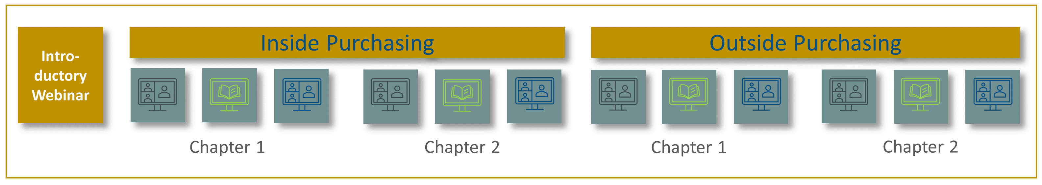
Programme structure and details



Awareness session
Virtual class
Self-study session

Programme details
1st course: |  | Fundamentals of Purchasing: Inside Purchasing
2nd course: |  | Fundamentals of Purchasing: Outside Purchasing
Sessions
Session 1 | Dates: | From 13th February to 17th April 2023
Session 1 | Mode: | Digital Learning including online group classes
Session 2 | Dates: | From 21st August to 9th October 2023
Session 2 | Mode: | Digital Learning including online group classes

Fees
EUR 1 600 ^{(*)}
(*): Prices are displayed free of VAT. Taxes will be calculated, if applicable, upon checkout.
Tick the chosen session: Session 1/2023 Session 2/2023

Invoicing information
Company / Organisation to be invoiced:
Invoicing department contact: Phone number:
Invoicing address:
City & Postal code: Country:
Purchase Order number (if requested): European VAT number:
How do you wish to make the payment?



Credit Card Credit Card type: (Diners card not accepted)
Credit card number: / / / Security code: Expiration date:
Card holder name: ___________________________________________________

Bank Transfer
Bank transfer in euros (€) payable to:
SAS EUROPEAN INSTITUTE OF PURCHASING MANAGEMENT
Bank: Crédit Agricole des Savoie – 2, Place de la Libération BP95 – 74160 SAINT JULIEN EN GENEVOIS – France
IBAN: FR76 1810 6000 3434 1626 7405 008 – SWIFT Code: AGRIFRPP881 – European VAT number: FR 913 930 946 28

IMPORTANT: Please specify the Invoice number when making the transfer

Payment terms
- Once the invoice is issued, the Company/participant is contractually obligated to pay the fee upon receipt of the invoice.
- Please note that, to be admitted, all fees are due and fully payable before the starting date of a course.

Cancellation / postponement policies
- Cancellations are accepted in writing up to 15 business days, prior to the scheduled course date. 50% of the course fees are refundable. After that date, the full course fee is payable.
- If you cannot attend the scheduled course, we can postpone your attendance or we can accept a substitute participant. No fee is applied for postponements or replacement of a participant.
- Under exceptional circumstances, EIPM reserves the right to postpone a course to an alternative date.

General terms
- The entire course material is provided under electronic format on the EIPM learning platform. Complementary training material is distributed to participants during the face-to-face training session, together with a welcome kit.

Agreement
I hereby confirm that I agree with the above terms and conditions.

Date: Click here to enter a date
Signature:

